 | WHAT TO EXPECT FROM YOUR HOSPITAL APPOINTMENT  (telephone, on-line or  face-to-face)

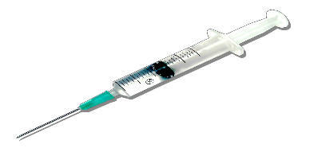 | Tests and Investigations  The specialist will order and arrange all of the tests you will need and will communicate the results to you. If you have not heard about your results, please contact their secretary at the hospital.

 | Prescriptions  If the specialist prescribes a new drug or changes one, they will provide the first prescription. You might need to collect it from the hospital pharmacy.

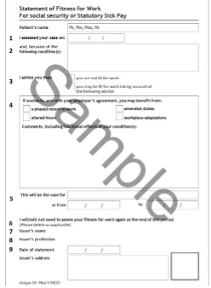 | Sick or Fit Note (Med 3)  If you need to be certified as unfit for work as a result of treatment provided, the specialist should issue a sick note when you leave the hospital. Please ask them if you need one.

 | Follow Up Appointments/Onward Referral  If you need a follow up appointment or an onward referral to another specialist, the hospital will provide it. Please ask the specialists’ secretary if it does not arrive in timely way.

In summary, the specialists are responsible for:
- Looking after your test results
- Providing a prescription when needed
- Issuing a sick note if required
- Providing you will follow up or onward referral appointment if necessary

